Basic Everyday Tips
1. Check Your Blind Spots
Check mirrors every 5-8 seconds to be aware of vehicles entering your blind spots. Additionally, scan ahead on the road about 15 seconds (equating to a quarter mile on interstates, or one to two blocks in cities) for traffic issues, work zones, and other dangers.
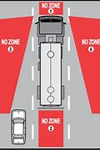
2. Be Aware of Long Stopping Distances
Large trucks and buses need the length of up to two football fields to safely stop. Driving too fast for weather or road conditions or failing to slow down for curves or ramps create risks for rollovers, as well as crashes. Be aware of long stopping distances and make careful wide turns.
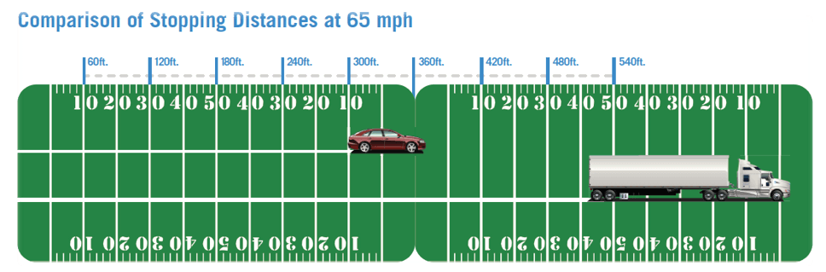
3. Make Wide Turns Carefully - Trucks need extra space and time to make wide, careful turns. Make turns carefully and signal appropriately.
4. Always Buckle Up - Fatal crashes are rising, and not wearing a seat belt is a key contributing factor. Wear your seat belt every time you drive or ride. Seat belts can save lives, reduce injuries, and allow drivers to stay inside and control their vehicles in the event of a crash
5. Drive at a Safe Speed - The large size and weight of trucks increase driving challenges, including acceleration, braking, and maneuverability. Large vehicles accelerate slower uphill and may gain speed quickly downhill. Drive at a safe speed, be aware of your surroundings, and never drive above the speed limit

