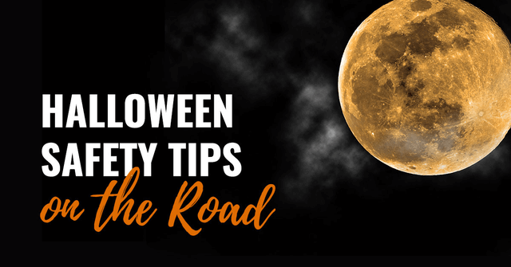

Watch for ghosts and goblins walking from house to house

Turn on your headlights to make yourself more visible

Be on the lookout for cars stopped on the side of the road

Avoid driving in residential areas where trick-or-treaters are likely to be